sottobosco  Rosso del Ticino  Denominazione di Origine Controllata |  | 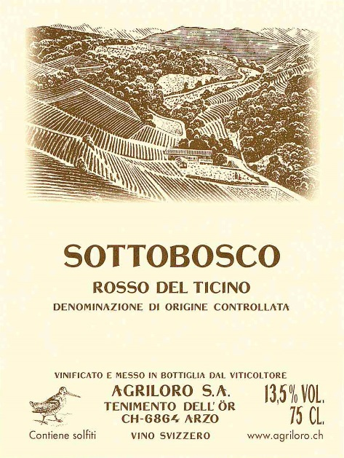
Production area | Hilly areas of Mendrisiotto.
Grape varieties | Merlot, Cabernet Sauvignon, Cabernet Franc, Petit Verdot.
Colour | Intense and brilliant ruby red with purple reflexes
Perfume | Intense and elegant, with a hint of black berries. Beautiful harmony between the grape varieties with a small dominance of Cabernet Sauvignon.
Flavour | Elegant, harmonious and well balanced. The tannins are quite present but well balanced by the acidity.
Aging | Over 10 anni
Alcohol | 13 Vol.%
Vinification | The different grape varieties are harvested and vinified separately. After 20 to 30 days of post fermentation skin contact the malolactic fermentation and following aging are made in French oak barriques for 20 months. The final blend is made straight before the bottling.
Serving | It is recommended to serve the wine at 18° C.
Gastronomic pairing | Main courses, red meat and cheese.

